The Impact of Lottery Incentives:

Increasing Response Rates Can Decrease Survey Accuracy

Jerold Pearson
Stanford Alumni Association
Stanford University
Arrillaga Alumni Center
Stanford, CA 94305

Roger E. Levine
American Institutes for Research
1070 Arastradero Road, Suite 200
Palo Alto, CA 94304-1334

Jon A. Krosnick
432 McClatchy Hall
450 Serra Mall
Stanford University
Stanford, CA 94305

January, 2010

Word Count = 2429

Jon Krosnick is University Fellow at Resources for the Future.

The Impact of Lottery Incentives:

Increasing Response Rates Can Decrease Survey Accuracy

Abstract

When offering incentives with a fixed budget, survey researchers can conduct lotteries with many winners of smaller prizes or with fewer winners of larger prizes. A respondent's expected value of the reward is the same, but one approach may be more psychologically compelling than the other. In an online survey of a listed sample, the present study randomly assigned each potential respondent to be offered five chances to win $100, one chance to win $500, or no incentive. Both incentive offers increased the survey's response rate significantly and equally, contradicting earlier research. Remarkably, the incentives decreased sample representativeness by increasing participation of subgroups that were already over-represented in the no-incentive condition. Thus, incentives may appear to be helpful when in fact they compromise survey accuracy, so future studies of incentive effects should explore their impact on sample composition as well as on response rates.

The Impact of Lottery Incentives:

Increasing Response Rates Can Decrease Survey Accuracy

INTRODUCTION
Survey researchers have been attentive to response rates for many years (Steeh 1981), and the response rate has been considered an important indicator of survey accuracy (Backstrom and Hursh 1963; Babbie 1990; Aday 1996; Rea and Parker 1997). But as response rates have declined – for mail (CASRO 1982), telephone (Holbrook, Krosnick, & Pfent 2007), and online (Sheehan 2001) surveys – researchers have explored and experimented with a range of issues related to survey participation. Among these issues are length of the survey, time in the field, salience, affiliation with the sponsor, design and appearance, type of postage and delivery method, pre-notifications, personalization, salutations, follow-ups, and refusal conversions (Peytchev, Baxter, & Carley-Baxter 2009; Healey, Macpherson, & Kuijten 2005; Pearson and Levine 2003; Edwards et al. 2002; Cook, Heath, & Thompson 2000; Dillman, Tortora, & Bowker 1998; Fox, Crask, & Kim 1988; Yu and Cooper 1983).
One issue related to survey response that continues to be of particular interest is incentives. Research has been conducted with a variety of incentives – including cash and other monetary incentives (both pre-paid and promised), charity donations, and lotteries – but the results have been varied. Some studies report that cash and pre-paid incentives increase response rates while lotteries, promised incentives, and charity donations do not (Singer, Van Hoewyk, & Maher 2000; Warriner et al. 1996; Hubbard and Little 1988). Other studies, however, report that lottery incentives do increase response rates (Balakrishnan et al. 1992; McCool 1991; for reviews, see Singer 2002, Church 1993).
While much effort has been invested in increasing response rates, attention has also been given to the consequences of these efforts. Some consumers of survey data assume that increasing the response rate is, in itself, a desired objective, but researchers have documented possible negative effects of incentives on response quality; item non-response; response distribution; and respondent motivation, honesty, and expectations (Singer, Van Hoewyk, & Maher 2000; Shettle and Mooney 1999; Baumgartner et al. 1998; Schwarz and Clore 1996; Brehm 1994; James and Bolstein 1990; for a review, see Singer 2002).
Another possible consequence of incentives – that can be either positive or negative – is their potential effect on sample composition: positive if the incentives increase response among subgroups that would otherwise be underrepresented (making the sample more representative of the population), but negative if they increase response rates among subgroups that are overrepresented (skewing the sample even further from the population).
Indeed, some studies have reported that incentives increase response among women (Whiteman et al. 2002; Duffer et al. 1994) and lower income individuals (Abreu, Martin, & Winters 1999; Mack et al. 1998; Singer et al. 1999; Kulka 1994). Studies have also reported that incentives increase response rates among respondents for whom the topic is of less salience (Groves, Singer, & Corning 1999; Shettle and Mooney 1999; Baumgartner and Rathbun 1997).
But what about respondents who feel less affinity with the sponsor of the survey? It seems likely that people who feel greater affinity would be more likely to respond to a survey invitation. Would incentives increase response among the others, who affiliate less closely and have a weaker relationship with the sponsor? If so, incentives could be of benefit by making the sample more representative of the population. Or, conversely, would incentives increase response rates even further among those who affiliate most closely with the sponsor? If that were the case, incentives would make things worse by further skewing the sample and making it even less representative.
The study described in this paper explored these issues by seeking to answer three questions: Do lottery incentives increase response to online surveys? What, if any, effect do incentives have on sample composition? What kind of lottery works best?
Prospect theory suggests that the way a proposition is framed can affect the decision people make (Tversky and Kahneman 1981), so is it more effective to offer respondents multiple chances to win a smaller gift, or to offer them a single chance to win a larger gift? If potential respondents focus mainly on the number of chances to win a prize, then offering them five chances to win $100 should be more motivating than offering them one chance to win $500. Conversely, if they focus mainly on the magnitude of the prize they might win, then offering them one chance to win $500 should be more motivating.
Deutskens, de Ruyter, Wetzels, and Oosterveld (2004) found “that lotteries with small prizes, but a higher chance of winning are most effective in increasing the response rate.” Our experiment explored this issue by testing two incentives of the same expected value (i.e., dollars multiplied by probability of winning) but framed differently, along with a control group offered no incentive.
METHODS
The population was defined as people who received degrees from Stanford University between 1955 and 2007, who live in the continental USA or Canada, and for whom Stanford had an e-mail address. Stanford employees and their spouses, current and former University Trustees, current and former members of the Stanford Alumni Association Board of Directors, and those who had requested to receive no e-mail were excluded from the study.
Three random samples of approximately 2,500 alumni were selected from the population, and each of the individuals was e-mailed a short invitation with a link to participate in the survey. The invitation was the same for all – except for the “subject” headers and the passages describing the incentive offered for their participation.
- Sample 1 was offered no incentive to participate in the survey.
- Sample 2 was informed that five randomly selected respondents (i.e., those who completed the survey) would each win a $100 Visa gift card.
- Sample 3 was informed that one randomly selected respondent would win a $500 Visa gift card.
The invitations were e-mailed on June 24, 2008, and three reminders were e-mailed to non-respondents at one-week intervals before the survey was taken off the web on July 20, 2008.
Names and demographic data came from Stanford’s alumni database. The demographic composition of the population and the three random samples is in the Appendix.
Class year was used as a proxy for age among undergraduate alumni:
- Class years 2000-2007: approximate ages 22-29.
- Class years 1990-1999: approximate ages 30-39.
- Class years 1980-1989: approximate ages 40-49.
- Class years 1970-1979: approximate ages 50-59.
- Class years 1955-1969: approximate ages 60 and older.
Class year cannot be used as a proxy for age among graduate alumni, mainly because the starting age of graduate students varies widely, but also because the time it takes to complete a graduate degree varies from program to program. Therefore, results reported by age refer only to undergraduate alumni.
In this paper, the term “graduate” alumni refers to people whose only degree from Stanford is a graduate degree. Those who have a graduate degree in addition to an undergraduate degree from Stanford are included in the “undergraduate” alumni group.
Because directionality was predicted for incentives, the statistical significance of differences in response rates between the incented samples and the non-incented sample was assessed through use of Fisher’s Exact Test (one-tailed). The statistical significance of differences in other response rates was assessed through use of the chi-square test.
RESULTS
Overall Response Rate
2,336 out of 7,333 alumni participated in the survey, for an overall response rate of 31.9%.
Response rates were higher among people with strong affiliations with the sponsor (see Figure 1). Specifically, the response rate was greater among:
- Donors (40.6%) than non-donors (26.5%) [p < .0001].
- Stanford Alumni Association members (36.4%) than non-members (26.3%) [p < .0001].
- Undergraduate alumni (35.0%) than graduate alumni (27.7%) [p < .0001].
As shown in Figure 2, the response rate was also somewhat greater among:
- Women (35.9%) than men (29.5%) [p < .0001].

- Alumni 50 and older than among alumni in their 30s and 40s [p < .001]. Response among alumni under 30 was between those groups, though not significantly different from either.
Incentives, Sample Composition, and Framing
Among all alumni, the incentives increased response rates from 30.6% in the non-incented group to 32.5% in the incented groups – a marginally significant difference of 1.9 percentage points [p = .057]. Effects of the incentives were also seen among certain demographic groups (see Figure 3):
- Donors and women responded at significantly higher rates (of 3.4 points each) to the incentives than to no incentive [p = .046 and p = .041, respectively].
- Alumni in their 30s and 40s responded at marginally significantly higher rates (of about 5 points) to the incentives than to no incentive [p = .057 and p = .066, respectively].
Within the other demographic groups, the response rate was, at most, a couple points higher in the incented samples than the non-incented sample, but these differences were not significant.
Higher response to the incentives among donors and women (but not among non-donors and men) is particularly noteworthy, because response without an incentive was also higher among donors and women – so not only did the incentives not improve the sample composition by increasing response among underrepresented groups, but the incentives in fact worsened the sample composition by further increasing the participation of overrepresented groups and magnifying the skew already present in the sample.
Without an incentive, women responded more than men did by 4.7 percentage points (33.6% vs 28.9%). But with an incentive, women responded more than men did by 7.3 percentage points – further increasing their disproportional response by another 55%. Similarly, without an incentive, donors responded more than non-donors did by 12.5 percentage points (38.3% vs 25.8%). But with an incentive, donors responded more than non-donors did by 14.9 percentage points (41.7% vs 26.8%) – further increasing their disproportional response by another 19%. (See Figure 4.)
Since the incentives drew a higher response among donors, but not among non-donors, it is possible that a sense of reciprocity provided donors extra motivation to participate (Cialdini 1984): they had given money to Stanford, now Stanford was offering to give money to them. Fair is fair; what goes around comes around.
The manipulation of the framing of the incentive had no effect on response rates, which were virtually identical to both incentives – 32.6% in Sample 2 (five chances to win $100) and 32.4% in Sample 3 (one chance to win $500). Moreover, similar response rates to the two incentives was consistent across all demographic groups: neither incentive outperformed the other within any specific demographic group. These results are contrary to those of Deutskens, de Ruyter, Wetzels, and Oosterveld (2004).
Multivariate logistic regressions were run to examine the independent effects of the incentives and demographic characteristics of the invited sample members. The dependent variable was participation in the survey (yes/no). The independent variables were donor status (donor/non-donor), Alumni Association status (member/non-member), degree level (undergraduate/graduate), class year (5 categories), gender (women/men), and treatment (incentive/no incentive).
People offered an incentive participated at a significantly higher rate than those not offered an incentive. Participation was also greater among donors, Alumni Association members, undergraduate alumni, and women, and people aged 30-39. (See Table 1.)
The incentive’s impact on response rates was concentrated exclusively among the group of people who had the highest response rate in the non-incented group: women who were donors and Stanford Alumni Association members. This group manifested an 8.1 percentage point increase in their response rate (p < .037), and no other groups manifested a significant increase. (See Table 2.)
Summary and Implications
As expected, response rates for this survey were higher among people who had stronger affiliations with the sponsor. Although offering incentives significantly increased the response rate, that increase was concentrated among people who were already over-represented in the non-incented sample, thus reducing the representativeness of the participating sample. Thus, the incentive’s impact was greatest for the very groups that needed it least, resulting in a sample that was even less representative with respect to these characteristics.
Furthermore, the impact on the survey response rate was statistically significant but small – 1.9 percentage points. Therefore, if it is of paramount importance to shake every last possible respondent from the trees, lottery style incentives in an online survey may be of some benefit. They may also be of benefit for surveys conducted exclusively among those groups most motivated by incentives (in this case, women and donors), when the increased participation of these groups will not make the sample less representative of the population. Lottery incentives might also be offered selectively if there is reason to believe these groups would otherwise be under-represented in the sample. But for many projects, incentives may not be worth the extra effort and cost, and may in fact compromise data quality.
If a lottery incentive is offered, it may not matter if respondents are offered multiple chances to win a smaller gift or a single chance to win a larger gift. In this experiment, response was the same for both – so neither proposition motivated more respondents than the other. Therefore, the expected value of an incentive (i.e., dollars multiplied by probability of winning) may be more important than the framing of the proposition. If so, larger or different incentives than the ones we tested might produce different results.
It is interesting to consider the cost per added complete of offering the incentives in this experiment. We achieved a 30.6% response rate in the unincented sample – so, without an incentive, we would have expected to obtain 1,500 respondents from the 4,903 invitations we sent to the two incented samples. In fact, we obtained 1,592 respondents from the two incented samples – 92 more than expected without incentives. The 92 extra respondents cost us $1000 in incentives, or $10.87 each. This is a remarkable price to pay for people who compromised the representativeness of the participating sample.
Because this experiment was conducted exclusively with degree holders from Stanford University, the participants were no doubt more affluent than many survey populations are (and thus perhaps less motivated by modest financial incentives). Likewise, they are more highly educated than many survey populations, and some response effects are less pronounced among highly educated respondents (Narayan and Krosnick 1996). So lottery incentives may result in greater differences with different populations. We look forward to future studies of this sort exploring these issues further. In the meantime, our findings reinforce the growing chorus of voices in the survey profession saying that higher response rates are not always indicators of increased survey accuracy, and expenditure of funds to increase response rates is not always wise.

References

Aadahl, Mette, and Torben Jorgensen. 2003. The effect of conducting a lottery on questionnaire response rates: a randomised controlled trial. European Journal of Epidemiology 18, No 10.

Abreu, Denise A., Elizabeth Martin, and Franklin Winters. 1999. Money and motive: results of an incentive experiment in the Survey of Income and Program Participation. Paper presented at the International Conference on Survey Nonresponse, in Portland, OR.

Aday, Lu Ann. 1996. Designing and Conducting Health Surveys. San Francisco: Jossey-Bass.

Babbie, Earl R. 1990. Survey Research Methods. Belmont, CA: Wadsworth Publishing Company.

Backstrom, Charles Herbert, and Gerald Hursh-Cesar. 1963. Survey Research. Evanston, IL: Northwestern University.

Balakrishnan, P. V., S. K. Chawla, M. F. Smith, and B. P. Micholski. 1992. Mail survey response rates using a lottery prize giveaway incentive. Journal of Direct Marketing 6: 54-59.

Baumgartner, Robert, and Pamela Rathbun. 1997. Prepaid monetary incentives and mail survey
response rates. Paper presented at the annual conference of the American Association of Public Opinion Research in Norfolk, VA.

Baumgartner, Robert, Pamela Rathbun, Kevin Boyle, Michael Welsh, and Drew Laughland.
1998. The effect of prepaid monetary incentives on mail survey response rates and response quality. Paper presented at the annual conference of the American Association of Public Opinion Research, in St. Louis, MO.

Brehm, John. 1994. Stubbing our toes for a foot in the door? Prior contact, incentives and survey response. International Journal of Public Opinion Research 6 (1): 45-63.

Church, Allan H. 1993. Incentives in mail surveys: a meta analysis. Public Opinion Quarterly 57: 62–79.

Cook, Colleen, Fred Heath, and Russel Thompson. 2000. A meta-analysis of response rates in web- or internet-based surveys. Educational and Psychological Measurement 60, No. 6: 821-836.

Council of American Survey Research Organizations (CASRO). 1982. “On the definition of response rates.” Special Report. New York: Council of American Survey Research Organizations.

Cialdini, Robert B. 1984. Influence. New York: Quill.

Deutskens, E., K. de Ruyter, M. Wetzels, and P. Oosterveld. 2004. Response rate and response quality of internet-based surveys: an experimental study. Marketing Letters 15, No 1.

Dillman, Don A., Robert D. Tortora, and Dennis Bowker. 1998. Principles for constructing web surveys. Social and Economic Sciences Research Center (SESRC) Technical Report. Washington State University.

Duffer, A., J. Lessler, M. Weeks, and W. Mosher. 1994. Effects of incentive payments on response rates and field costs in a pretest of a national CAPI survey. Proceedings of the Survey Research Section. Alexandria, VA: American Statistical Association.

Edwards, Phil, Ian Roberts, Mike Clarke, Carolyn DiGuiseppi, Sarah Pratap, Reinhard Wentz, and Irene Kwan. 2002. Increasing response rates to postal questionnaires: systematic review. British Medical Journal.

Fox, Richard J., Melvin Crask, and Jonghoon Kim. 1988. Mail survey response rate: a meta-
analysis of selected techniques for inducing response. Public Opinion Quarterly 52: 467-91.

Groves, Robert M. 2007. Nonresponse rates and nonresponse bias in household surveys. Public Opinion Quarterly 70: 646-675.

Groves, Robert M., Eleanor Singer, and Amy D. Corning. 1999. “Decision-making in survey
participation: theory and a test.” Unpublished manuscript.

Healey, Benjamin, Terry MacPherson, and Bart Kuijten. 2005. An empirical evaluation of three web survey design principles. Marketing Bulletin 16: 1-9.

Holbrook, Allyson L., Jon A. Krosnick, and Alison Pfent. 2007. “Response rates in surveys by the news media and government contractor survey research firms.” In Telephone Survey Methodology, ed. J. Lepkowski, B. Harris-Kojetin, P. J. Lavrakas, C. Tucker, E. de Leeuw, M. Link, M. Brick, L. Japec, and R. Sangster. New York: Wiley.

Hubbard, Raymond, and Eldon L. Little. 1988. Promised contributions to charity and mail
survey responses: replication with extension. Public Opinion Quarterly 52: 223-30.

James, Jeannine M., and Richard Bolstein. 1990. The effect of monetary incentives and
follow-up mailings on the response rate and response quality in mail surveys. Public Opinion Quarterly 54: 346-61.

Kulka, Richard. 1994. The use of incentives to survey ‘hard-to-reach’ respondents: a brief
review of empirical research and current practice. Paper presented at the Seminar on New
Directions in Statistical Methodology, Council of Professsional Agencies on Federal Statistics, May 25, in Washington, DC.

Mack, Stephen, Vicki Huggins, Donald Keathley, and Mahdi Sundukchi. 1998. Do monetary
incentives improve response rates in the Survey of Income and Program Participation? Proceedings of the Section on Survey Methodology. American Statistical Association.

McCool, Steven F. 1991. Using probabilistic incentives to increase response rates to mail
return highway intercept diaries. Journal of Travel Research 30: 17-19.

Narayan, Sowmya, and Jon A. Krosnick. 1996. Education moderates some response effects in attitude measurement. Public Opinion Quarterly 60: 58-88.

Pearson, Jerold, and Roger E. Levine. 2003. Salutations and response rates to online surveys. Proceedings of the Fourth International Conference on the Impact of Technology on the Survey Process. Association for Survey Computing.

Peytchev, Andy, Rodney K. Baxter, and Lisa R. Carley-Baxter. 2009. Not all survey effort is equal: reduction of nonresponse bias and nonresponse error. Public Opinion Quarterly 73: 785-806.

Rea, Louis M., and Richard A. Parker. 1997. Designing and Conducting Survey Research: A Comprehensive Guide. San Francisco: Jossey–Bass.

Schwarz, Norbert, and Gerald L. Clore. 1996. “Feelings and phenomenal experiences.” In Social Psychology: Handbook of Basic Principles, ed. E. T. Higgins and A. Kruglanski. New York: Guilford.

Sheehan, Kim. 2001. E-mail survey response rates: a review. Journal of Computer-Mediated Communication.

Shettle, Carolyn, and Geraldine Mooney. 1999. Monetary incentives in government surveys.
Journal of Official Statistics 15: 231-50.

Singer, Eleanor. 2002. “The use of incentives to reduce nonresponse in household surveys.” In Survey Nonresponse, ed. Groves, Robert M., Dillman, Don A., Eltinge, John L., Little, Roderick J. A. New York: Wiley.

Singer, Eleanor, Robert M. Groves, and Amy D. Corning. 1999. Differential incentives: beliefs
about practices, perceptions of equity, and effects on survey participation. Public Opinion
Quarterly 63: 251–60.

Singer, Eleanor, John Van Hoewyk, and Mary P. Maher. 2000. Experiments with incentives in telephone surveys. Public Opinion Quarterly 64: 171–188.

Steeh, Charlotte. 1981. Trends in nonresponse rates: 1952-1979. Public Opinion Quarterly 45: 40-57.

Tversky, Amos, and Daniel Kahneman. 1981. The framing of decisions and psychology of choice. Science 211: 453-458.
Warriner, Keith, John Goyder, Heidi Gjertsen, Paula Hohner, and Kathleen McSpurren. 1996.
Charities, no; lotteries, no; cash, yes: main effects and interactions in a Canadian incentives experiment. Public Opinion Quarterly 60: 542-562

Whiteman, Maura K., Patricia Langenberg, Kristen Kjerulff, Robert McCarter, and Jodi Anne Flaws. 2002. A randomized trial of incentives to improve response rates to a mailed women's health questionnaire. Journal of Women’s Health.

Yu, Julie, and Harris Cooper. 1983. A quantitative review of research design effects on response
rates to questionnaires. Journal of Marketing Research 20: 36–44.

Appendix: Response Rates

 | All three samples |  |  | Sample 1: No Incentive |  |  | Sample 2: 5 $100 Gifts |  |  | Sample 3: 1 $500 Gift
 | % of | Response |  | % of | Response |  | % of | Response |  | % of | Response
 | Sample | Rate |  | Sample | Rate |  | Sample | Rate |  | Sample | Rate
All | 100% | 31.9% |  | 100% | 30.6% |  | 100% | 32.6% |  | 100% | 32.4%
Men | 62.9% | 29.5% |  | 63.1% | 28.9% |  | 61.9% | 29.9% |  | 63.7% | 29.6%
Women | 37.1% | 35.9% |  | 36.9% | 33.6% |  | 38.1% | 36.9% |  | 36.3% | 37.1%
SAA | 55.1% | 36.4% |  | 56.3% | 35.3% |  | 54.8% | 37.6% |  | 54.2% | 36.3%
Non-member | 44.9% | 26.3% |  | 43.7% | 24.6% |  | 45.2% | 26.5% |  | 45.8% | 27.7%
Donor | 38.1% | 40.6% |  | 38.2% | 38.3% |  | 37.4% | 42.6% |  | 38.6% | 40.8%
Non-donor | 61.9% | 26.5% |  | 61.8% | 25.8% |  | 62.6% | 26.6% |  | 61.4% | 27.0%
Undergrad | 57.3% | 35.0% |  | 58.4% | 33.7% |  | 55.8% | 35.3% |  | 57.7% | 35.9%
Graduate | 42.7% | 27.7% |  | 41.6% | 26.3% |  | 44.2% | 29.1% |  | 42.3% | 27.5%
22-30 (undergrad 2000-2007) | 10.4% | 35.0% |  | 10.9% | 34.0% |  | 10.0% | 33.1% |  | 10.3% | 38.1%
30-39 (undergrad 1990-1999) | 14.1% | 32.3% |  | 14.0% | 28.9% |  | 13.4% | 32.8% |  | 14.9% | 35.1%
40-49 (undergrad 1980-1989) | 11.5% | 32.6% |  | 11.2% | 28.9% |  | 11.2% | 33.8% |  | 11.9% | 34.9%
50-59 (undergrad 1970-1979) | 10.6% | 38.3% |  | 10.9% | 40.4% |  | 10.7% | 41.1% |  | 10.1% | 33.1%
60+ (undergrad 1955-1969 ) | 10.8% | 37.6% |  | 11.4% | 37.5% |  | 10.4% | 36.5% |  | 10.6% | 38.8%

Figure 1

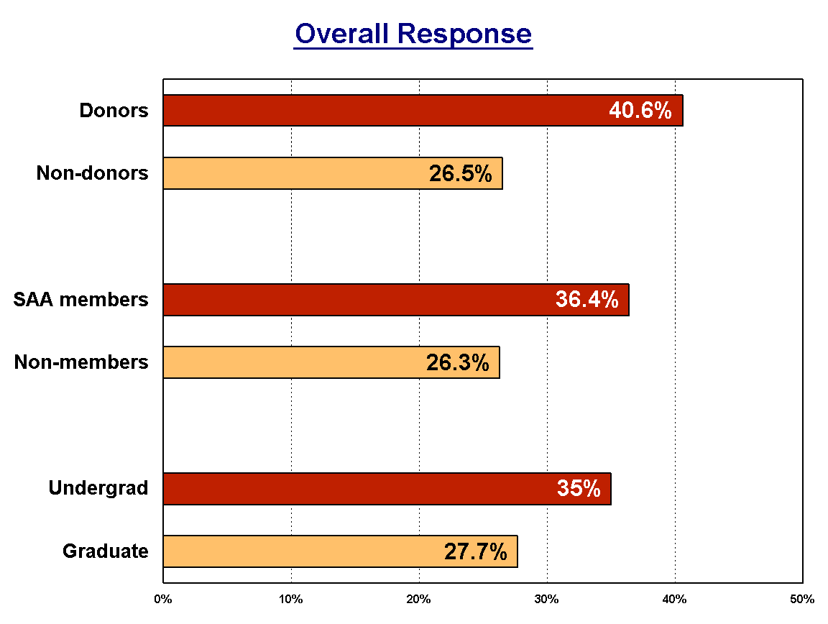

Figure 2

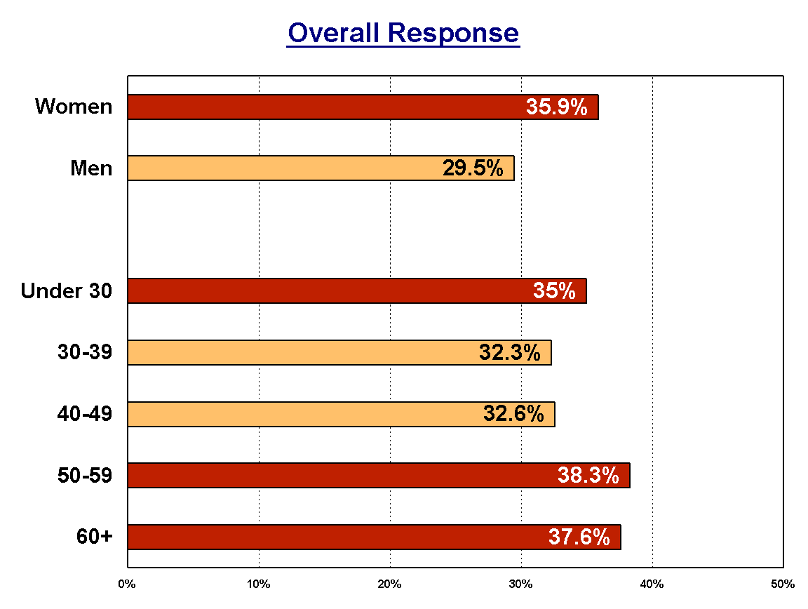

Figure 3

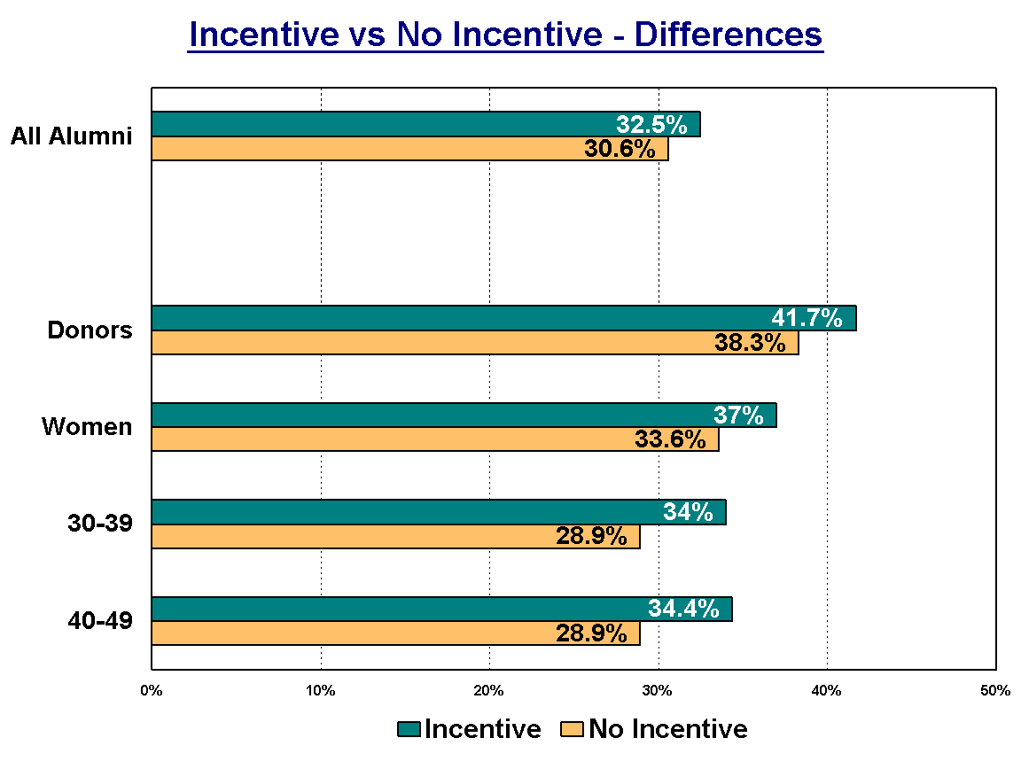

Figure 4

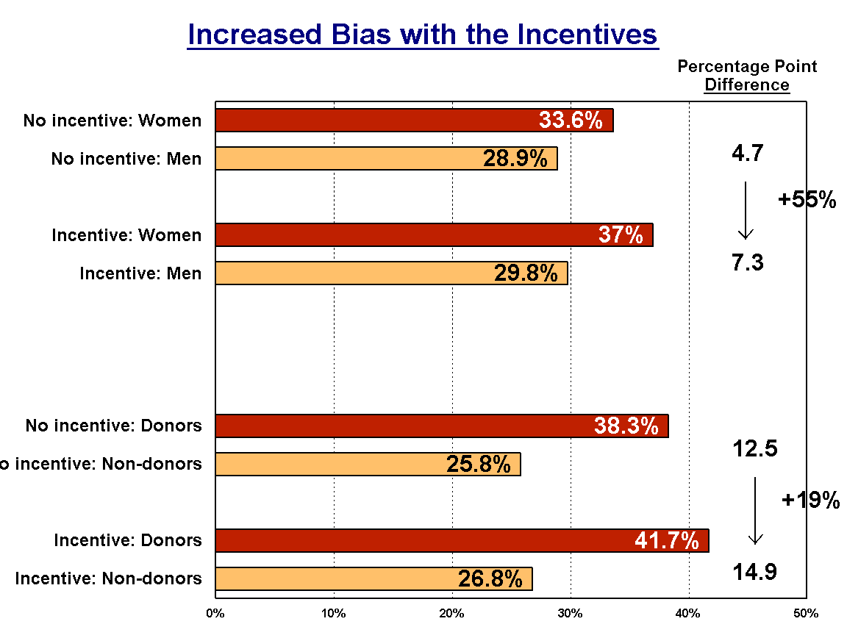

Table 1: Effects of Incentives and Demographic Characteristics on Survey Participation

Predictor | Coefficient | Standard  Error | Probability
Offered an incentive | 0.10 | 0.06 | .034
Donor | 0.33 | 0.03 | < .0001
Alumni Association member | 0.19 | 0.03 | < .0001
Undergraduate degree | 0.08 | 0.03 | .019
Women | -0.27 | 0.05 | < .0001
Age 60 and older (undergrad 1955-1969) | -0.01 | 0.05 | .703
Age 50-59 (undergrad 1970-1979) | -0.01 | 0.05 | .915
Age 40-49 (undergrad 1980-1989) | -0.08 | 0.05 | .120
Age 30-39 (undergrad 1990-1999) | -0.14 | 0.05 | .002
Omitted (reference) groups: Non-donors, Alumni Association non-members, graduate alumni, men, people aged 22-30 (undergraduate 2000-2007), and not offered an incentive.

Table 2: Response Rates by Selected Respondent Characteristics as a Function of Incentives

 | Men |  |  |  | Women
 | Donor |  | Non-donor |  | Donor |  | Non-donor
Respondent  Group | SAA | Non-SAA | SAA | Non-SAA | SAA | Non-SAA | SAA | Non-SAA
No incentive | 37.2% | 31.4% | 29.7% | 20.9% | 44.9% | 38.2% | 32.7% | 22.3%
Incentive | 39.1% | 34.6% | 28.0% | 22.7% | 53.0% | 37.7% | 34.0% | 26.0%
Difference | 1.9% | 3.2% | -1.7% | 1.8% | 8.1% | -0.5% | 1.3% | 3.7%
N | 1,175 | 536 | 1,342 | 1,560 | 745 | 338 | 778 | 859
Note: SAA = Stanford Alumni Association Member

People who had asked to receive no surveys were removed from the three random samples (N = 2,499, 2,513, and 2,510), leaving samples of 2,452, 2,478, and 2,478. Invitations were e-mailed to these people, and a few bounced back as undeliverable (N=22, 29, and 24, respectively), yielding final participating samples of 2,430, 2,449, and 2,454.
Since our hypothesis regarding the impact of incentives was directional, a one-tailed test was used. All other tests are two-tailed.

